**Installation Process**

1. Open the file driver_64bit.exe.

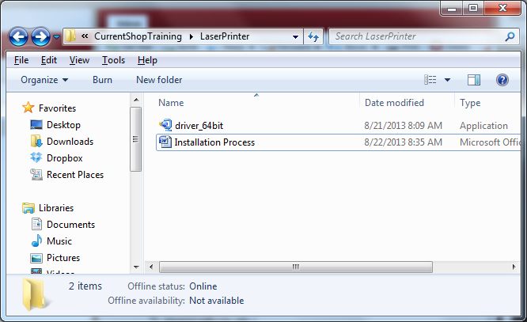

1. A window will come up prompting you to Unzip the file. Remember this location as you’ll need it later in the install process
   1. . Click the Unzip button.

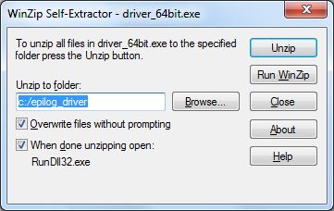

1. Once the files have been extracted, a prompt will appear informing you of this.
   1. Click OK

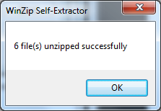

1. Next the computer will ask you the type of printer you wish to install.
   1. Click ‘Add a network, wireless or Bluetooth printer’

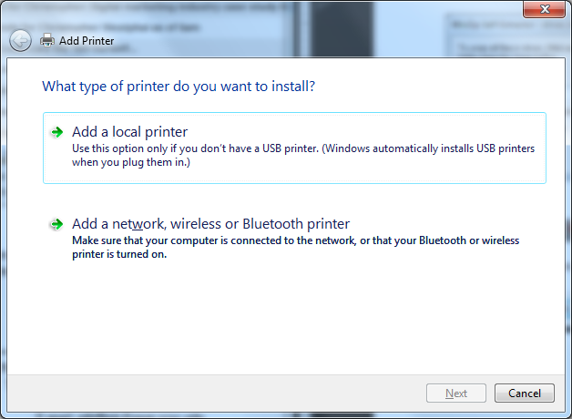

1. When you click the ‘Add a network, wireless or Bluetooth printer’, the computer will try to be smarter than you and find the printer, but today you are smarter than the computer! The computer will report back a list of printers it found but the one you want is not listed.
   1. Click ‘The printer that I want isn’t listed’

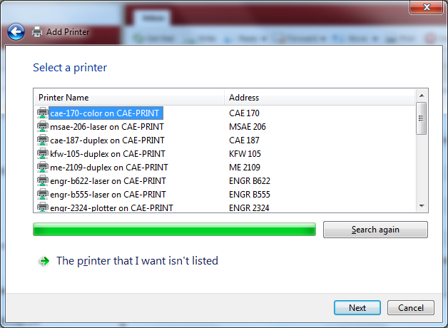

1. The next window that appears will ask you how you want to find the printer.
   1. Click the radio button labeled ‘Add a printer using a TCP/IP address or hostname’
   2. Click Next

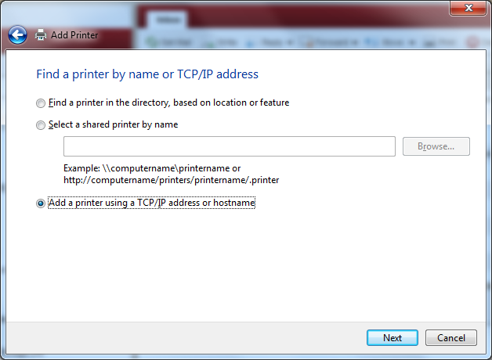

1. Next you’ll be prompted to type a printer hostname or IP address.
   1. Under Device type, select TCP/IP Device.
   2. In the Hostname or IP address box type:
      1. 128.104.194.126
   3. Uncheck ‘Query the printer and automatically select the driver to use’

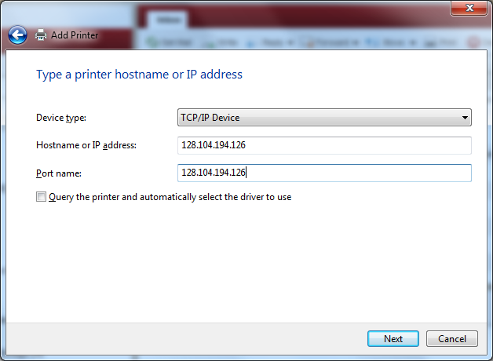

1. The computer will try to redeem itself and try to find the printer for you.

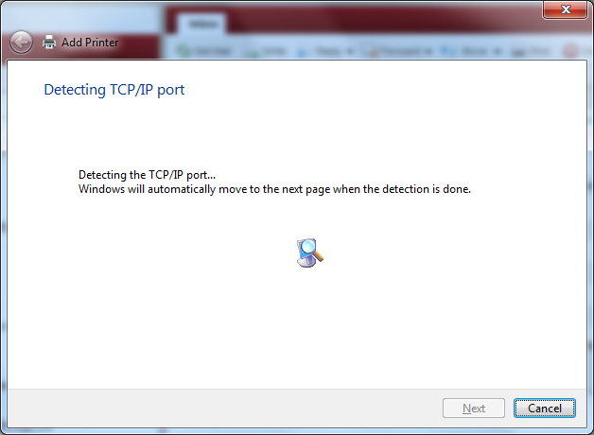

1. After a valiant effort, it will report back that it could not find the printer. It is now time for you to intervene.
   1. Click the radio button labeled ‘Custom’.
   2. This will enable the ‘Settings…’. Click the ‘Settings…’ button.

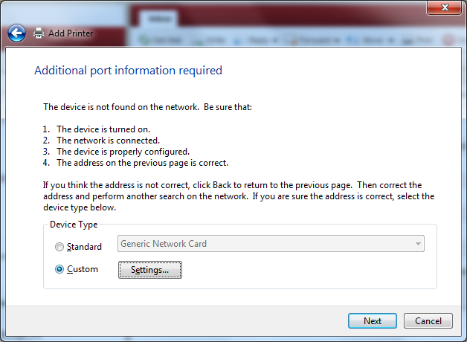

1. This will open the port settings dialog box.
   1. In the Protocol section, click the radio button labeled ‘LPR’
   2. In the LPR Settings section type the word Legend in the Queue Name box.
   3. Click OK

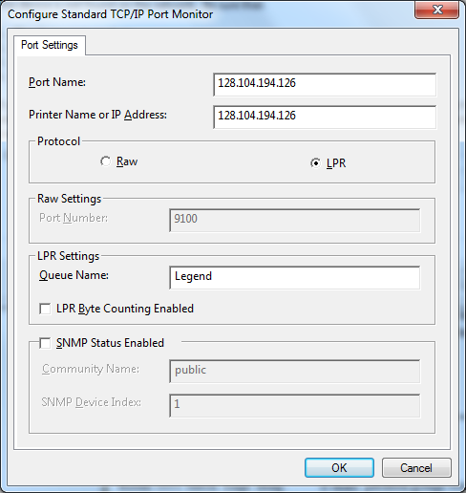

1. This will return you to the previous screen.
   1. Click Next.

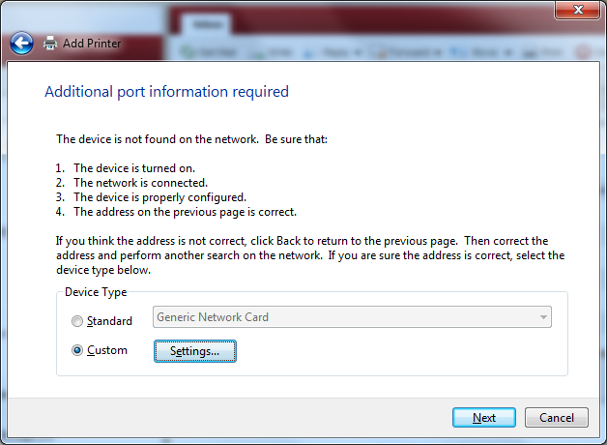

1. The next window will prompt you to choose a printer from a list. The laser printer is not in the list so we have to direct the computer to the location where the drivers are located.
   1. Click the button ‘Have Disk…’

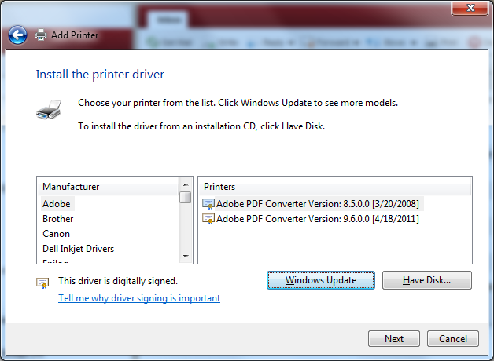

1. To install from the disk, you must point the computer to the location where the files were unzipped in Step 2.
   1. Click the ‘Browse…’ button and navigate to the folder ‘Mini_Helix_EXT’ which will be in the ‘epilog_driver’ folder. The default path should be C:\epilog_driver\Mini_Helix_EXT.
   2. Click OK once you have browsed to the correct location.

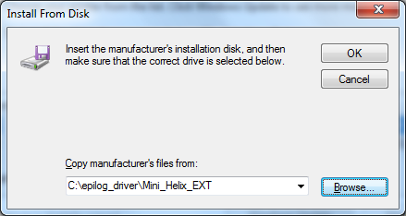

1. This will send you back to the previous screen where it will notify you that the driver is not digitally signed (it could be dangerous; however, if you want to use the laser cutter you have no option other than to be okay with it).
   1. Click Next.

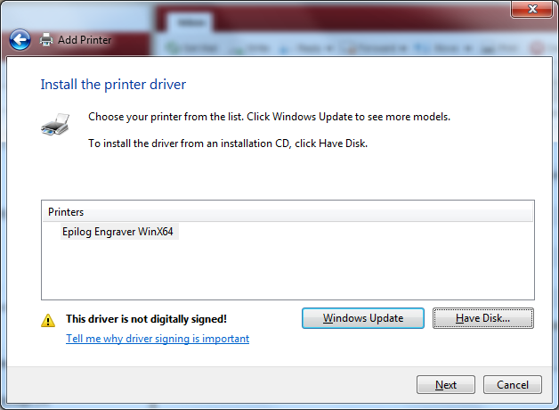

1. The next screen allows you to name the printer. A suggest name is Epilog Engraver
   1. Type the name of the printer you desire
   2. Click Next

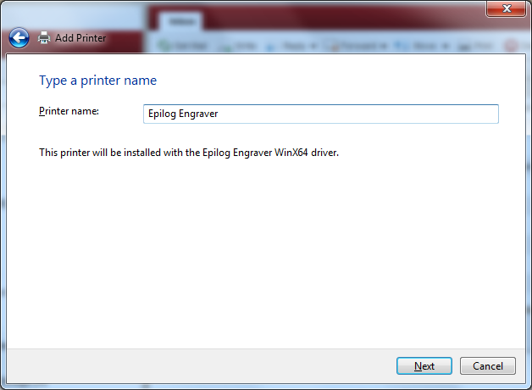

1. Following the naming of the printer is whether or not to share this printer. This choice doesn’t really matter here so click whichever you desire.
   1. Click either radio button.
   2. Click Next.

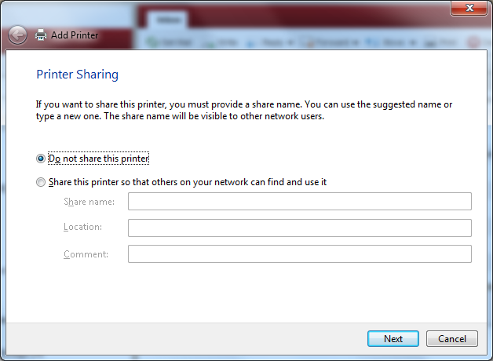

1. You have now successfully installed the printer. You are given a choice to set the printer as the default (not recommended).
   1. Uncheck the box labeled ‘Set as the default printer’
   2. Click Finish

